Be carefull with desserts!!
There is a new disease discovered, it’s a very dangerous disease,
this diseaseis called lucosis.
It’s founded in a dessert. The dessert is called muches.
U can only heal lucosis when you don’t eat vegetables for 6 months, except a very rare
Vegetable. This vegetable is called linoptis. It’s only available
In Thailand. The symptoms of lucosis are:
- You’re gonna get the chicken pox again.
- You’re gonna have a high temperature.
- You’re gonna get oppresive. This is linoptis This is muches

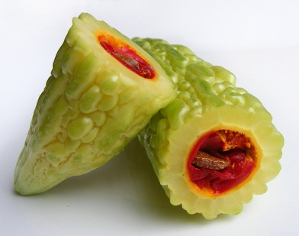

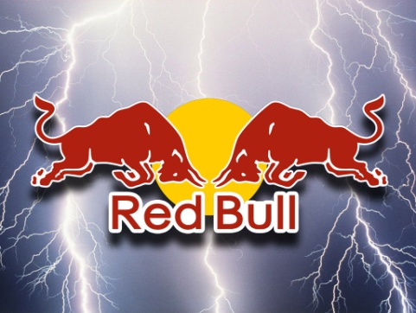
Red Bull
It has energy drink, it has crashed ice,
It has it all! So if you are smart, you will
Come see red Bull crashed ice.
If you are stupid, you just stay home
And watch tv. (rtl7 redbull crashed ice)

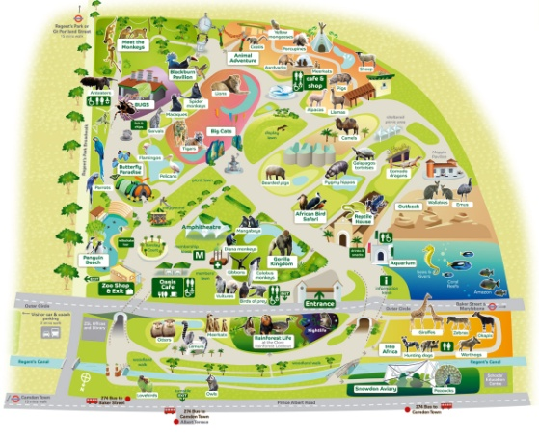
London zoo
The london zoo, is a very great zoo.
Its not big, but there are the most
beautifull animals. You don’t have to
pay mutch, so why wouldn’t you go?

