Philippines
The Philippines consist of islands.
The most famous curiosities are:
- Shopping
- Luxurious hotels
- A beautiful view
- The Chocolate Mountains
- The Islands of Philippines
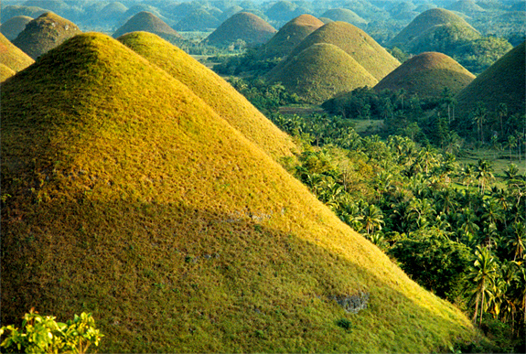
There are lots of activities. You can have a massage and you can also go to the wellness centre. You can go dive in the sea and swim with fishes and coral. You can also go to beach. Go for a walk in the beautiful Chocolate Mountains. In the Philippines, there is a beautiful weather, so there is also a beautiful nature. There are lots of hotels in the Philippines, all of them are comfortable and beautiful. And if you want you can reserve a room with a swimming pool.
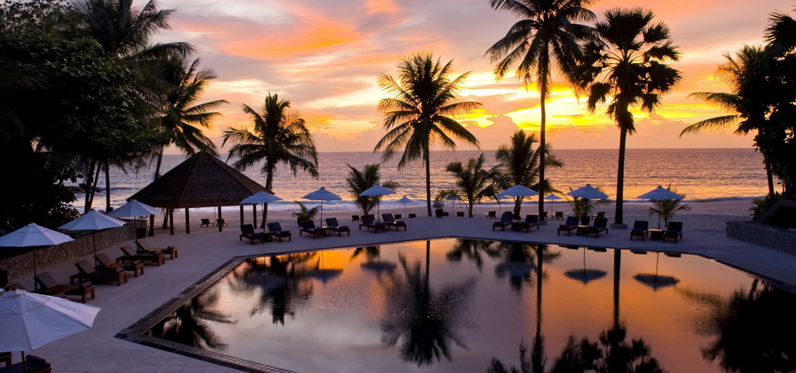

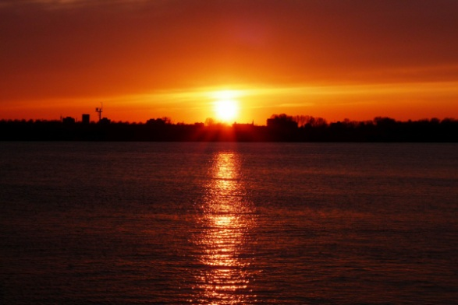
Watch from your balcony the beautiful sunset or sunrise above the horizon.

The capital of the Philippines is manila, there is no beach, but you can go to the night life and then totally forget there’s no beach
here in the city.


Shopping is a very lovely way to spend your time. There are lots of shopping areas. You can go to one of them, and if you want to go to another one, it’s 10 minutes away! You can buy clothes, accessories, jewelry, shoes and other things.

You can book your holiday trip here:

- http://www.philippineholiday.com
- http://www.luxuryholidaysdirect.com
- http://www.malaysiaairlines.com

